Study Guide for Plant Taxonomy Quiz on Wednesday November 4, 2015

Keep an eye to the BIG PICTURE—I may ask a question or two about how everything fits together!

Magnoliid Clade
What characters resolve magnoliids into a separate clade (for example: molecular synapomorphies and secondary chemistry), monophyletic group including the Magnoliales, Laurales, Canellales & Piperales, perianth parts spiral or whorls of 3, sources of spices, stamens frequently poorly differentiated, be able to describe the foliage & calyx & corolla & androecium & gynoecium & fruit of the Magnoliaceae, Myristicaceae, Lauraceae, Piperaceae, Aristolochiaceae, and Saururaceae
General Monocots
Embryo with a single cotyledon– remains the best morphological synapomorphy of monocots
Other monocot characteristics (but not necessarily synapomorphies since there are many exceptions) : parallel veined leaves, fibrous roots, herbaceous habit, scattered vascular bundles, leaves formed at the basal end of the leaf primordium (= intercalary meristem), monosulcate pollen, DNA sequence evidence, flower parts in 3’s.
What is a cotyledon (leaf or leaves developed at first embryonic node) and how do they differ from endosperm? Ploidy level of endosperm vs. cotyledons.
No vascular cambium (i.e., no wood) in monocots although they can grow thicker by virtue of anomalous (secondary thickening) meristem
Know the foliage/calyx/corolla/androecium/gynoecium/fruit for Lilliaceae, Melanthiaceae, Agavaceae, Iridaceae, Orchidaceae, Poaceae.

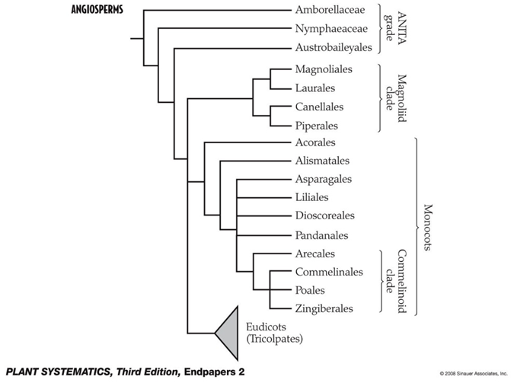

Family | Foliage | Calyx | Corolla | Androecium | Gynoecium | Fruit
Magnoliid Clade
Magnoliaceae | Trees/shrubs blade with pellucid dots containing ethereal oils (aromatic terpenoids) | Tepals distinct | Tepals distinct | Many undifferentiated stamens | Numerous distinct, superior | aggregate of follicles, seed red, dangles
Myristicaceae | bark exudes reddish sap; blades with pellucid dots containing ethereal oils; contains myristicin (=hallucinogen | Three connate tepals | Three connate tepals | filaments connate into a solid column; stamens 2 to numerous | one ovule, ovary superior | leathery follicle, large seed, colorful aril
Lauraceae | contain ethereal oils (made from 5 carbon fragment called terpenoid) | Usually 6 tepals | Usually 6 tepals | filaments with nectar producing appendages; stamens 3-12 | one carpel, ovary superior | Drupe or one seeded berry
Piperaceae | contains ethereal oils | No perianth! Spikes of thick, minute flowers | No perianth! Spikes of thick, minute flowers | filaments distinct; stamens 1-10 | 1 ovule per gynoecium, superior | drupe
Aristolochiaceae | ethereal oils with pellucid dots and aristolochic acids, bitter yellow nitrogenous compounds | connate, showy, dull red, mottled | missing | filaments adnate to style; stamens 6-12 | 4-6 carpels, inferior ovary | Septicidal capsule
Saururaceae | with ethereal oils | Absent-- Flowers with a single petaloid bract | Absent-- Flowers with a single petaloid bract | 3-8 distinct stamens | 3-4 carpels united at the base; superior | capsule

Family | Foliage | Calyx | Corolla | Androecium | Gynoecium | Fruit
Monocots (non-Commelinoid Clade)
Liliaceae | bulbs or rhizomes, parallel venation | Six distinct tepals | Six distinct tepals | Stamens 6, filaments distinct | 3 connate carpels, ovary superior | Loculicidal capsule
Melanthiaceae | poisonous alkaloids often present (hence the “Death Camas Family”!) | 6 mostly distinct tepals | 6 mostly distinct tepals | usually 6 distinct stamens | 3-10 connate carpels, usually 3 distinct styles; superior to slightly inferior | capsule
Agavaceae | leaves smooth with marginal fibers in Yucca; leaves toothed in Agave | 6 distinct tepals | 6 distinct tepals | 6 distinct stamens | 3 connate carpels; ovary superior in Yucca, inferior in Agave | loculicidal capsule, seeds with black phytomelan crust
Iridaceae | Equitant (& conduplicate) | 6 tepals, inner somewhat differentiated from outer | 6 tepals, inner somewhat differentiated from outer | Three distinct filaments, specialized pollination anatomy | Three connate carpels, inferior ovary | Loculicidal capsule
Orchidaceae | Roots strongly mycorrhizal, parallel venation and sheathing at the base | 6 Tepals, inner 3 and outer 3 somewhat differentiated, one of the inner ones forming the labellum | 6 Tepals, inner 3 and outer 3 somewhat differentiated, one of the inner ones forming the labellum | stamens fused to stigma forming a column; pollen forming masses called pollinia | ovary inferior, 3 carpels, stigma highly modified | capsule/minute seeds; seeds lacking endosperm

Family | Foliage | Calyx | Corolla | Androecium | Gynoecium | Fruit
Monocots (Commelinoid Clade)
Commelinaceae | Grass like, sheathing at the base; flowers enclosed in spathe sometimes | Three, distinct | Three distinct, usually clawed | 3 or 6 stamens, sometimes with conspicuous hairs (Tradescantia) | Ovary superior, 3 connate carpels | Loculicidal capsule; seeds with conspicuous conical cap, bullet shaped
Poaceae | Divided into blade and sheath; ligule at junction; sometimes with auricle; stem=culm | Special flower anatomy c/o flower, floret, lemma, palea, glumes, lodicule, etc. | Special flower anatomy c/o flower, floret, lemma, palea, glumes, lodicule, etc. | 3 distinct stamens | 3 superior carpels that appear as two but only produce one grain | Grain= caryopsis

Plant Taxonomy Plant ID list 2015:
Euphorbia (term to know: cyathium) in the EUPHORBIACEAE
Tribulus (terms to know: schizocarp, actinomorphic vs. zygomorphic=bilateral symmetry) in the ZYGOPHYLLACEAE
Chamaesyce (terms to know: serrate, pubescent) in the EUPHORBIACEAE
Ipomopsis (term to know: exserted) in the POLEMONIACEAE
Sphaeralcea (term to know: monadelphous) in the MALVACEAE
Hesperidanthus (terms to know: tetradynamous, silique, clawed petal) in the BRASSICACEAE
Phaseolus (term to know: keel= 2 fused petals, papilionaceous) in the FABACEAE
Guilleminea in the AMARANTHACEAE
Helianthus (terms to know: phyllary, Involucre) in the ASTERACEAE
Juncus (term to know: rhizome vs. stolon) in the JUNCACEAE
Castilleja (terms to know: hemiparasite vs. holoparasite) in the OROBANCHACEAE
Boerhavia (term to know: involucre) in the NYCTAGINACEAE
Croton (term to know: dioecious) in the EUPHORBIACEAE
Solanum (term to know: sympetalous) in the SOLANACEAE
Mentha (term to know: anthocyanins) in the LAMIACEAE
Berula (term to know: umbel) in the APIACEAE
Anemopsis (term to know: Magnoliid) in the SAURURACEAE
Verbena in the VERBENACEAE
Kochia (term to know: betalains) in the CHENOPODIACEAE
Argemone (term to know: caducous) in the PAPAVERACEAE
Polanisia in the CLEOMACEAE
Eriogonum in the POLYGONACEAE
Lepidium in the BRASSICACEAE
Phoradendron in the SANTALACEAE
Froelichia in the AMARANTHACEAE
Ephedra (term to know: Gnetophyte) in the EPHEDRACEAE
Vitis in the VITACEAE (term to know: tendril)
Crotalaria in the FABACEAE
Kraschenninikovia in the CHENOPODIACEAE
Ptelea in the RUTACEAE (terms to know: pellucid dots, ethereal oils)
Drymaria in the CARYOPHYLLACEAE
Ambrosia in the ASTERACEAE

